Exercise 7

- List the names of 5 youngest employees in the company.
SELECT f_name, l_name FROM employee_data ORDER BY age ASC LIMIT 5;
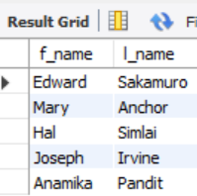
- Extract the next 5 entries starting with the 10 row.
SELECT * FROM employee_data LIMIT 5 OFFSET 9;
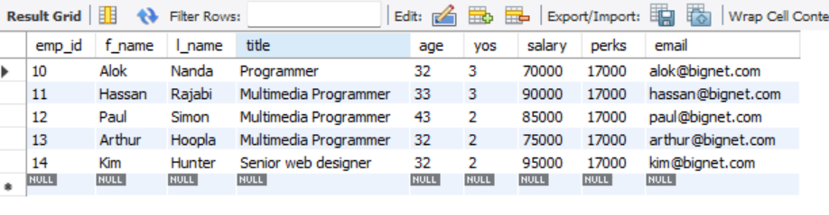
- Display the names and salary of the employee who draws the largest salary.
SELECT f_name, l_name, salary FROM employee_data WHERE salary = (SELECT MAX(salary) FROM employee_data);
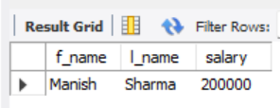
- What does the following statement display?
SELECT emp_id, age, perks FROM employee_data ORDER BY perks desc limit 10;
